Interdisciplinary Polish Studies at Loyola University
and Polish Student Alliance
invite you to a

Polish film screening and discussion

with director Magdalena Lazarkiewicz

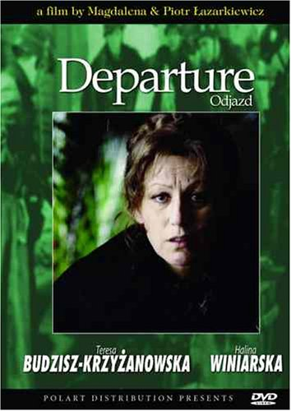

Monday, November 7 at 4:00 pm
Crown Center 104
Free admission and refreshments

